# Visvesvaraya Technological University

**“Jnana Sangama”, VTU-Campus, Belagavi-590018**



## 2024 – 2025

**LABORATORY JOURNAL OF**

**ALGORITHMS & ARTIFICIAL INTELLIGENCE**

**LABORATORY (MCSL106)**

**Submitted By:**

**Swapnadeep Kapuri**

**2VX24SCS17**

**M.Tech in CSE 1St Sem**

**Department of Computer Science and Engineering**

# Visvesvaraya Technological University

**“Jnana Sangama”, VTU-Campus, Belagavi-590018**



**Department of Computer Science and Engineering**

Certificate

This is to certify that **Mr. Swapnadeep Kapuri (2VX24SCS17)** has satisfactorily completed the Laboratory Experiments for **Algorithms and AI Laboratory (MCSL106)** during the academic year 2024-25.

|  |  |  |
| --- | --- | --- |
| Faculty In Charge | Course Coordinator | Chairperson |
| **Dr. Shanmukhappa Angadi** | **Dr. Shanmukhappa Angadi** | **Dr S.L.Deshpande** |
| **Dr. Rashmi R Rachh** |  |  |

### Name of Examiner and Signature 1.

**2.**

**INDEX**

|  |  |  |  |
| --- | --- | --- | --- |
| **SL NO.** | **NAME OF THE PROGRAMS** | **PAGE**  **NO** | **DATE** |
| **1** | **Implement a simple linear regression algorithm to predict a continuous target variable based on a given dataset.** |  |  |
| **2** | **Develop a program to implement a Support Vector Machine for binary classification. Use a sample dataset and visualize**  **the decision boundary** |  |  |
| **3** | **Develop a simple case-based reasoning system that stores instances of past cases. Implement a retrieval method to find**  **the most similar cases and make predictions based on them.** |  |  |
| **4** | **Write a program to demonstrate the ID3 decision tree algorithm using an appropriate dataset for classification.** |  |  |
| **5** | **Build an Artificial Neural Network by implementing the Backpropagation algorithm and test it with suitable datasets.** |  |  |
| **6** | **Implement a KNN algorithm for regression tasks instead of**  **classification. Use a small dataset, and predict continuous values based on the average of the nearest neighbors** |  |  |
| **7** | **Create a program that calculates different distance metrics (Euclidean and Manhattan) between two points in a dataset. Allow the user to input two points and display the calculated distances.** |  |  |
| **8** | **Implement the k-Nearest Neighbor algorithm to classify the Iris dataset, printing both correct and incorrect predictions.** |  |  |
| **9** | **Develop a program to implement the non-parametric Locally Weighted Regression algorithm, fitting data points and visualizing results.** |  |  |
| **10** | **Implement a Q-learning algorithm to navigate a simple grid environment, defining the reward structure and analyzing**  **agent performance.** |  |  |

## Program 1: Implement a simple linear regression algorithm to predict a continuous target variable based on a given data set.

import numpy as np

import matplotlib.pyplot as plt

from sklearn.linear_model import LinearRegression from sklearn.model_selection import train_test_split from sklearn.metrics import mean_squared_error

### # Generate synthetic data

np.random.seed(42)

X = 2 * np.random.rand(100, 1)

y = 4 + 3 * X + np.random.randn(100, 1)

### # Split the data into training and testing sets

X_train, X_test, y_train, y_test = train_test_split(X, y, test_size=0.2, random_state=42)

### # Train the model

model = LinearRegression() model.fit(X_train, y_train)

**# Print model parameters** print(f"Intercept: {model.intercept_[0]}") print(f"Coefficient: {model.coef_[0][0]}")

### # Make predictions

y_pred = model.predict(X_test)

### # Compute mean squared error

mse = mean_squared_error(y_test, y_pred) print(f"Mean Squared Error: {mse}")

### # Plot the results

plt.scatter(X, y, color='blue', label='Data')

plt.plot(X, model.predict(X), color='red', linewidth=2, label='Regression Line') plt.xlabel('Feature Set X-Axis')

plt.ylabel('Target Data Set Y-Axis') plt.title('Simple Linear Regression') plt.legend()

plt.show()

## Output:

Intercept: 4.142913319458566

Coefficient: 2.7993236574802762

Mean Squared Error: 0.6536995137170021

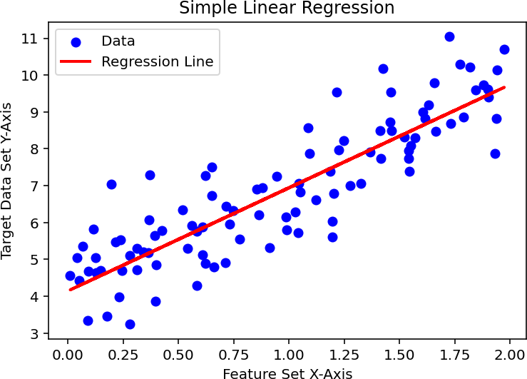

## Program 2: Develop a program to implement a Support Vector Machine for binary classification. Use a sample data set and visualize the decision boundary.

import matplotlib.pyplot as plt from sklearn import datasets

from sklearn.model_selection import train_test_split from sklearn.svm import SVC

from mlxtend.plotting import plot_decision_regions

### # Generate a synthetic dataset

X, y = datasets.make_classification(n_samples=100, n_features=2,

n_classes=2, n_clusters_per_class=1, n_redundant=0, random_state=42)

### # Split the dataset into training and testing sets

X_train, X_test, y_train, y_test = train_test_split(X, y,

test_size=0.2, random_state=42)

### # Train an SVM classifier

svm = SVC(kernel='linear', C=1.0, random_state=42) svm.fit(X_train, y_train)

**# Plot decision boundary** plt.figure(figsize=(8, 6)) plot_decision_regions(X, y, clf=svm, legend=2) plt.xlabel("Feature 1")

plt.ylabel("Feature 2") plt.title("SVM Decision Boundary") plt.show()

### # Print model accuracy

accuracy = svm.score(X_test, y_test) print(f"\nModel Accuracy: {accuracy * 100:.2f}% ")

## Output:

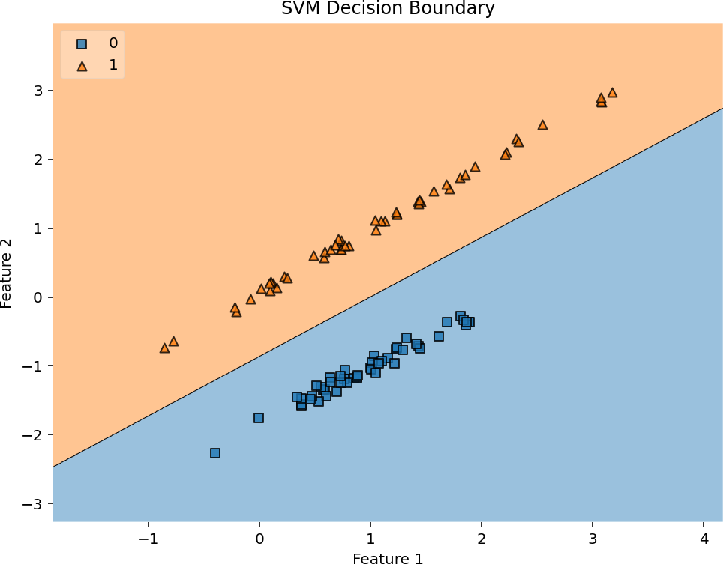

Model Accuracy: 100.00%

## Program 3: Develop a simple case-based reasoning system that stores instances of the past cases. Implement a retrieval method to find the most similar cases and make predictions based on them.

import numpy as np

import matplotlib.pyplot as plt

from sklearn.neighbors import NearestNeighbors from sklearn.datasets import make_regression from sklearn.preprocessing import StandardScaler

### # Generate a sample dataset (100 past cases)

X, y = make_regression(n_samples=100, n_features=1, noise=10, random_state=42) scaler = StandardScaler()

X_scaled = scaler.fit_transform(X) **# Normalize for better distance calculation**

### # Case-Based Reasoning (CBR) Function

def retrieve_similar_cases(X_cases, y_cases, new_case, n_similar=3):

### """Finds the most similar past cases using Euclidean distance."""

nbrs = NearestNeighbors(n_neighbors=n_similar, metric='euclidean').fit(X_cases) distances, indices = nbrs.kneighbors(new_case) **# FIXED: Removed extra brackets** return indices[0], distances[0]

### # New case to predict

new_case = np.array([[0.5]]) **# Example new input**

new_case_scaled = scaler.transform(new_case) **# Keeps it 2D**

### # Retrieve most similar cases

similar_indices, similar_distances = retrieve_similar_cases(X_scaled, y, new_case_scaled) similar_cases = X[similar_indices] **# Original scale for visualization**

predicted_value = np.mean(y[similar_indices]) **# Average output of similar cases**

### # Output results

print(f"New Case Input: {new_case.flatten()[0]:.2f}") print(f"Most Similar Cases (X values): {similar_cases.flatten()}") print(f"Corresponding Outputs (y values): {y[similar_indices]}") print(f"Predicted Output: {predicted_value:.2f}")

### # Plot cases and prediction

plt.scatter(X, y, label="Past Cases", color="blue", alpha=0.6)

plt.scatter(similar_cases, y[similar_indices], label="Similar Cases", color="red", marker="s", s=100) plt.scatter(new_case, predicted_value, label="Predicted Case", color="green", marker="*", s=150) plt.xlabel("Feature Value")

plt.ylabel("Output Value")

plt.title("Case-Based Reasoning Prediction") plt.legend()

plt.show()

## Output:

New Case Input: 0.50

Most Similar Cases (X values): [0.49671415 0.51326743 0.54256004]

Corresponding Outputs (y values): [16.77823077 20.05162924 5.91200699]

Predicted Output: 14.25

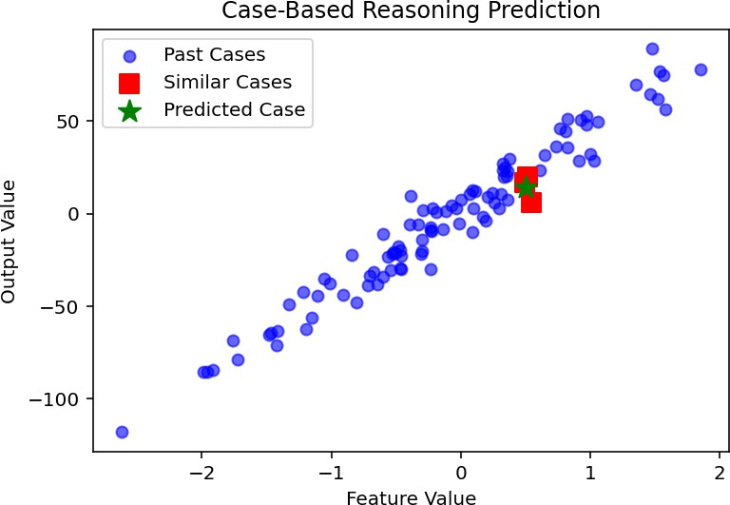

## Program 4: Write a program to demonstrate the ID3 decision tree algorithm using an appropriate dataset for classification.

import pandas as pd

import matplotlib.pyplot as plt

from sklearn.tree import DecisionTreeClassifier, plot_tree from sklearn.datasets import load_iris

from sklearn.model_selection import train_test_split

### # Load dataset (Iris dataset for classification)

iris = load_iris()

X, y = iris.data, iris.target feature_names = iris.feature_names class_names = iris.target_names

### # Split into training and testing sets

X_train, X_test, y_train, y_test = train_test_split(X, y, test_size=0.2, random_state=42)

### # Train Decision Tree Classifier using ID3 (entropy-based)

clf = DecisionTreeClassifier(criterion='entropy', random_state=42) clf.fit(X_train, y_train)

### # Plot the decision tree

plt.figure(figsize=(12, 6))

plot_tree(clf, feature_names=feature_names, class_names=class_names, filled=True) plt.title("Decision Tree using ID3 Algorithm")

plt.show()

### # Print model accuracy

accuracy = clf.score(X_test, y_test)

print(f"\nModel Accuracy: {accuracy * 100:.2f}% ")

### # Print feature importance

feature_importance = pd.DataFrame({'Feature': feature_names, 'Importance': clf.feature_importances_}) print("\nFeature Importance:\n", feature_importance.sort_values(by='Importance', ascending=False))

## Output:

Model Accuracy: 100.00% Feature Importance:

Feature Importance

|  |  |
| --- | --- |
| 2 petal length (cm) | 0.895406 |
| 3 petal width (cm) | 0.090107 |
| 1 sepal width (cm) | 0.014487 |
| 0 sepal length (cm) | 0.000000 |

## Program 5: Build an Artificial Neural Network by implementing the Backpropagation algorithm and test it with suitable datasets.

### (Note: TensorFlow module is still not compatible with Python 3.12.8!!! Use Python 3.10/3.11 or use Google Colab to work the below code)

import numpy as np

from tensorflow import keras

from sklearn.datasets import load_iris

from sklearn.model_selection import train_test_split

from sklearn.preprocessing import OneHotEncoder, StandardScaler

### # Load dataset (Iris dataset for classification)

iris = load_iris()

X, y = iris.data, iris.target

### # One-hot encode target labels (Fix: Use sparse_output instead of sparse)

encoder = OneHotEncoder(sparse_output=False) y = encoder.fit_transform(y.reshape(-1, 1))

### # Split into training and testing sets

X_train, X_test, y_train, y_test = train_test_split(X, y, test_size=0.2, random_state=42)

### # Standardize features

scaler = StandardScaler()

X_train = scaler.fit_transform(X_train) X_test = scaler.transform(X_test)

### # Build the Neural Network model

model = keras.Sequential([

keras.layers.Dense(10, activation='relu', input_shape=(X_train.shape[1],)), # Hidden Layer 1 keras.layers.Dense(10, activation='relu'), # Hidden Layer 2

keras.layers.Dense(y.shape[1], activation='softmax') # Output Layer (3 classes)

])

### # Compile the model

model.compile(optimizer='adam', loss='categorical_crossentropy', metrics=['accuracy'])

### # Train the model

history = model.fit(X_train, y_train, epochs=100, batch_size=10, validation_data=(X_test, y_test), verbose=1)

### # Evaluate model performance

test_loss, test_accuracy = model.evaluate(X_test, y_test) print(f"\nModel Accuracy on Test Data: {test_accuracy * 100:.2f}% ")

### # Predict on test data

y_pred = model.predict(X_test) y_pred_classes = np.argmax(y_pred, axis=1) y_test_classes = np.argmax(y_test, axis=1)

### # Display some predictions

print("\nSample Predictions (True vs Predicted Labels):") print(np.vstack((y_test_classes[:10], y_pred_classes[:10])).T)

## Output:

Model Accuracy on Test Data: 100.00%

1/1 ━━━━━━━━━━━━━━━━━━━━ 0s 69ms/step

Sample Predictions (True vs Predicted Labels): [[1 1]

[0 0]

[2 2]

[1 1]

[1 1]

[0 0]

[1 1]

[2 2]

[1 1]

[1 1]]

## Program 6: Implement a KNN algorithm for regression tasks instead of classification. Use a small dataset, and predict continuous values based on the average of the nearest neighbors.

import numpy as np

import matplotlib.pyplot as plt

from sklearn.model_selection import train_test_split from sklearn.neighbors import KNeighborsRegressor from sklearn.metrics import mean_squared_error

### # Generate a small dataset

np.random.seed(42)

X = np.sort(5 * np.random.rand(20, 1), axis=0) # Feature

y = np.sin(X).ravel() + np.random.normal(0, 0.1, X.shape[0]) # Target with noise

### # Split dataset into training and testing sets

X_train, X_test, y_train, y_test = train_test_split(X, y, test_size=0.2, random_state=42)

### # Implement KNN Regression

k = 3 # Number of neighbors

knn_regressor = KNeighborsRegressor(n_neighbors=k, weights='uniform') knn_regressor.fit(X_train, y_train)

### # Predict on test set

y_pred = knn_regressor.predict(X_test)

### # Compute Mean Squared Error

mse = mean_squared_error(y_test, y_pred) print(f"Mean Squared Error: {mse:.4f}")

### # Plot results

plt.scatter(X, y, color='blue', label='Data') plt.plot(X_test, y_pred, 'ro', label='Predictions') plt.xlabel("Feature")

plt.ylabel("Target")

plt.title(f"KNN Regression (k={k})") plt.legend()

plt.show()

## Output:

Mean Squared Error: 0.1636

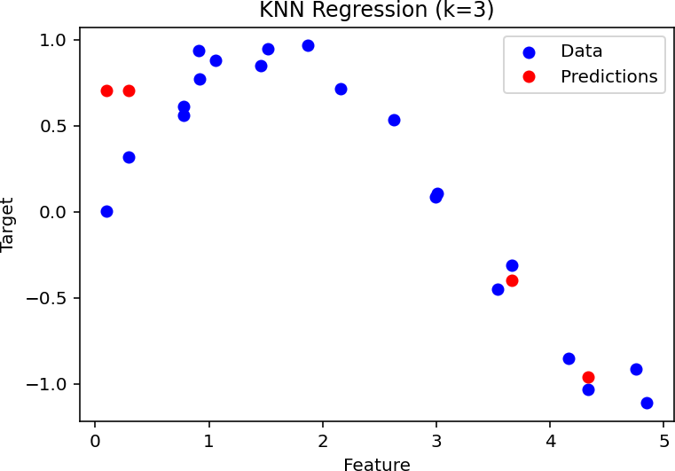

## Program 7: Create a program that calculates different distance metrics (Euclidean and Manhattan) between two points in a dataset. Allow the user to input two points and display the calculated distances.

import numpy as np

def euclidean_distance(point1, point2):

### """Compute Euclidean distance between two points."""

return np.sqrt(np.sum((np.array(point1) - np.array(point2)) ** 2))

def manhattan_distance(point1, point2):

### """Compute Manhattan distance between two points."""

return np.sum(np.abs(np.array(point1) - np.array(point2)))

def get_coordinates():

### """Get valid user input for coordinates."""

while True: try:

coords = list(map(float, input().strip().split())) return coords

except ValueError:

print("Invalid input! Please enter numeric values separated by spaces.")

def main():

print("Enter the coordinates of two points (space-separated):")

print("Point 1: ", end="") point1 = get_coordinates()

print("Point 2: ", end="") point2 = get_coordinates()

### # Check if dimensions match

if len(point1) != len(point2):

print("Error: Points must have the same number of dimensions.") return

### # Calculate distances

euclidean = euclidean_distance(point1, point2) manhattan = manhattan_distance(point1, point2)

### # Print results

print("\nDistance Calculations:") print(f"Euclidean Distance : {euclidean:.4f}") print(f"Manhattan Distance : {manhattan:.4f}")

if name == " main ": try:

main()

except Exception as e:

print(f"An error occurred: {e}")

## Output:

Enter the coordinates of two points (space-separated): Point 1: 3 4

Point 2: 7 1

Distance Calculations: Euclidean Distance : 5.0000 Manhattan Distance : 7.0000

## Program 8: Implement the k-Nearest Neighbor algorithm to classify the Iris dataset, printing both correct and incorrect predictions.

from sklearn.datasets import load_iris

from sklearn.model_selection import train_test_split from sklearn.neighbors import KNeighborsClassifier

### # Load dataset

iris = load_iris()

X, y = iris.data, iris.target

### # Split into training and testing sets

X_train, X_test, y_train, y_test = train_test_split(X, y, test_size=0.2, random_state=42)

### # Train k-NN classifier

knn = KNeighborsClassifier(n_neighbors=3) knn.fit(X_train, y_train)

### # Make predictions

y_pred = knn.predict(X_test)

### # Print correct and incorrect predictions

for i in range(len(y_test)):

print(f"Predicted: {y_pred[i]}, Actual: {y_test[i]}, {'Correct' if y_pred[i] == y_test[i] else 'Incorrect'}")

## Output:

Predicted: 1, Actual: 1, Correct

Predicted: 0, Actual: 0, Correct

Predicted: 2, Actual: 2, Correct

Predicted: 1, Actual: 1, Correct

Predicted: 1, Actual: 1, Correct

Predicted: 0, Actual: 0, Correct

Predicted: 1, Actual: 1, Correct

Predicted: 2, Actual: 2, Correct

Predicted: 1, Actual: 1, Correct

Predicted: 1, Actual: 1, Correct

Predicted: 2, Actual: 2, Correct

Predicted: 0, Actual: 0, Correct

Predicted: 0, Actual: 0, Correct

Predicted: 0, Actual: 0, Correct

Predicted: 0, Actual: 0, Correct

Predicted: 1, Actual: 1, Correct

Predicted: 2, Actual: 2, Correct

Predicted: 1, Actual: 1, Correct

Predicted: 1, Actual: 1, Correct

Predicted: 2, Actual: 2, Correct

Predicted: 0, Actual: 0, Correct

Predicted: 2, Actual: 2, Correct

Predicted: 0, Actual: 0, Correct

Predicted: 2, Actual: 2, Correct

Predicted: 2, Actual: 2, Correct

Predicted: 2, Actual: 2, Correct

Predicted: 2, Actual: 2, Correct

Predicted: 2, Actual: 2, Correct

Predicted: 0, Actual: 0, Correct

Predicted: 0, Actual: 0, Correct

## Program 9: Develop a program to implement the non-parametric Locally Weighted Regression Algorithm, fitting data points and visualizing results.

import numpy as np

import matplotlib.pyplot as plt

def kernel_weight(query_x, X, tau):

### """Compute weights using a Gaussian kernel."""

query_x = np.array(query_x).reshape(1, -1) **# Ensure query_x is 2D**

distances = np.linalg.norm(X - query_x, axis=1) ** 2 **# Compute squared distances**

weights = np.exp(-distances / (2 * tau ** 2)) **# Gaussian kernel**

return np.diag(weights) **# Return diagonal weight matrix**

def locally_weighted_regression(X, y, tau, query_points): **"""Perform Locally Weighted Regression."""** X_bias = np.c_[np.ones(len(X)), X] # Add bias term y_pred = []

for query_x in query_points:

query_x_bias = np.hstack(([1], query_x.ravel())) **# Ensure 1D array**

W = kernel_weight(query_x, X, tau) **# Compute weight matrix**

theta = np.linalg.pinv(X_bias.T @ W @ X_bias) @ (X_bias.T @ W @ y**) # Compute parameters**

y_pred.append(query_x_bias @ theta) **# Predict value**

return np.array(y_pred)

### # Generate sample data

np.random.seed(42)

X = np.linspace(-3, 3, 30).reshape(-1, 1) # Reshape X to be a 2D column vector

y = np.sin(X).flatten() + np.random.normal(scale=0.2, size=X.shape[0]) **# True function with noise**

### # Define test points for visualization

X_test = np.linspace(-3, 3, 100).reshape(-1, 1) # Reshape X_test to 2D

### # Perform LWR with bandwidth parameter tau

tau = 0.5 **# Smoothing parameter**

y_pred = locally_weighted_regression(X, y, tau, X_test)

### # Plot original data and LWR curve

plt.scatter(X, y, label="Data Points", color="blue", alpha=0.6)

plt.plot(X_test, y_pred, label=f"LWR Curve (τ={tau})", color="red", linewidth=2) plt.xlabel("X")

plt.ylabel("y")

plt.title("Locally Weighted Regression (LWR)") plt.legend()

plt.show()

## Output:

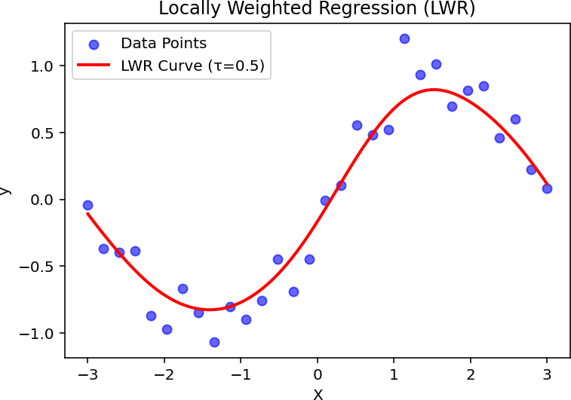

**Program 10: Implement a Q-learning algorithm to navigate a simple grid environment, defining the reward structure and analyzing agent performance.**

import numpy as np

import matplotlib.pyplot as plt import seaborn as sns

### # Grid & Hyperparameters

GRID_SIZE, GAMMA, ALPHA, EPSILON, EPISODES = 5, 0.9, 0.1, 0.2, 500

ACTIONS = {'up': (-1, 0), 'down': (1, 0), 'left': (0, -1), 'right': (0, 1)}

START, GOAL = (0, 0), (4, 4)

Q_table = np.zeros((GRID_SIZE, GRID_SIZE, len(ACTIONS)))

### # Reward grid (-1 per step, +10 goal, -10 wall)

REWARD_GRID = np.full((GRID_SIZE, GRID_SIZE), -1)

REWARD_GRID[GOAL] = 10

def move(state, action):

### """Returns the next state & reward."""

next_state = (state[0] + action[0], state[1] + action[1])

return (state, -10) if not (0 <= next_state[0] < GRID_SIZE and 0 <= next_state[1] < GRID_SIZE) else (next_state, REWARD_GRID[next_state])

def choose_action(state):

### """Epsilon-greedy action selection."""

return np.random.choice(list(ACTIONS)) if np.random.rand() < EPSILON else list(ACTIONS)[np.argmax(Q_table[state])]

def train():

### """Q-learning training loop."""

rewards = []

for episode in range(EPISODES): state, total_reward = START, 0 while state != GOAL:

action = choose_action(state)

next_state, reward = move(state, ACTIONS[action])

Q_table[state][list(ACTIONS).index(action)] += ALPHA * (reward + GAMMA * np.max(Q_table[next_state]) - Q_table[state][list(ACTIONS).index(action)])

state, total_reward = next_state, total_reward + reward rewards.append(total_reward)

return rewards

### # Run training & visualize results

rewards = train()

plt.plot(rewards) plt.xlabel("Episodes") plt.ylabel("Total Reward") plt.title("Q-learning Performance") plt.show()

sns.heatmap(np.max(Q_table, axis=2), annot=True, cmap="coolwarm", fmt=".2f") plt.title("Q-values Heatmap")

plt.show()

## Output:

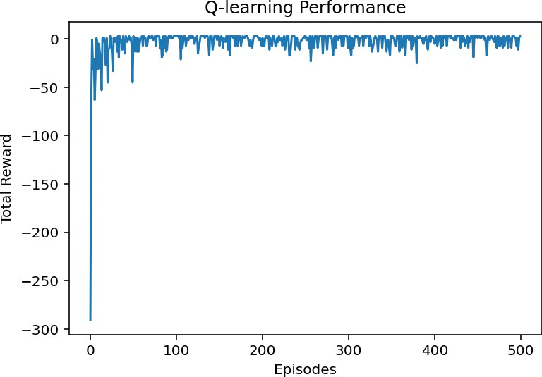

### (Note: The above graph chart is done by using pyplot library from Matplotlib module.)

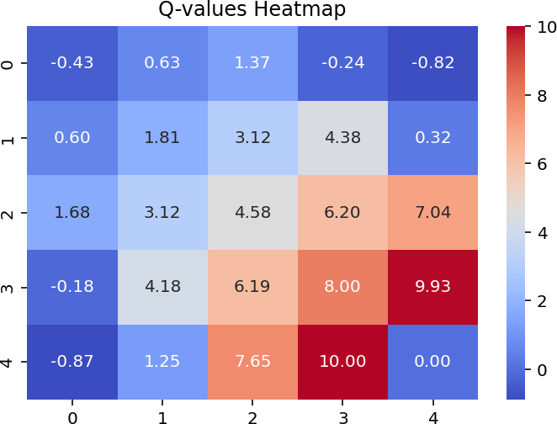**(Note: The above heat map is done by using Seaborn library.) Graph of Rewards Over Episodes**

* **Early episodes**: Low rewards (random moves).
* **Later episodes**: Higher rewards (better paths).

### Q-values Heatmap

* **Brighter values** show **stronger Q-values** (good moves).

### The goal state has the highest Q-value.

**Python Requirements:**

* Install Python 3.12.8 or 3.10
* Then install the following libraries/modules of python:
  + pip install spyder
  + pip install seaborn
  + pip install matplotlib
  + pip install scikit-learn
  + pip install mlxtend
  + pip install tensorflow
  + pip install numpy
  + pip install scipy
  + pip install pandas